**What we have done last weeks:**

Found SkiaSharp in Visual Studio (the solution that can draw lines based on the coordinates of vertices).

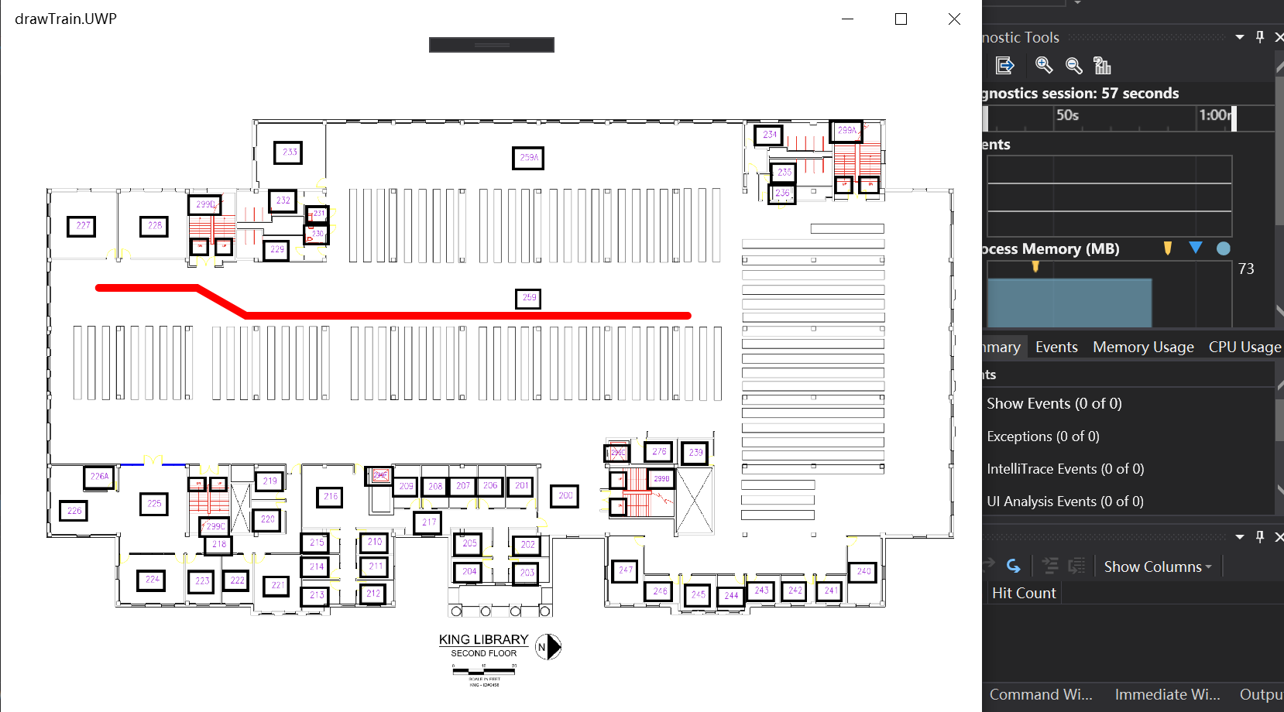

[Video](https://drive.google.com/drive/u/1/folders/1xQYEVKwL25PrxnNVX1Tcrd0O05oWnEfJ): How to transfer pdf map to grid map data.

**The progress since the last week:**

Still learning how to use SQL lite.

WenKai is currently locating the shelves on the second floor by hand.

**What will be starting this week:**

Integrate parts together:

1. Combine the SkiaSharp(drawing path), and the local map together (Not ready for applying algorithm into the app yet, or maybe one of target if we can do this quickly).
2. Install the algorithm into the C# code (written by java first)
3. Install mapping system into the app
4. Starting coding functions we need on mobile phones.

**Conclusion:**

We lowered our progress speed these weeks since the uncertainty happens while looking for solutions and time spent on learning new technology, also heavy homework assignments and Exams are coming.